On the beat in  Wem  Safer Neighbourhood Team Newsletter | October 2023

Who we are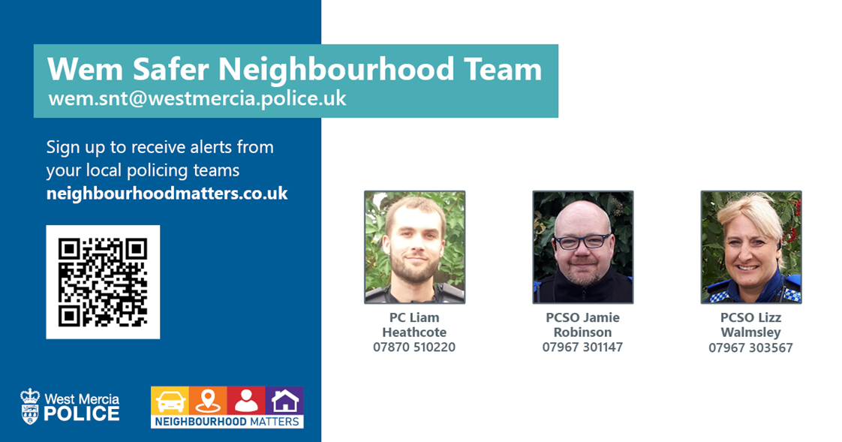
Burglary- x 3
RTC- x 2
Vehicle Crime- x 1
Highways Incident- x 0
Assaults- x 9
Domestic incidents- x 7
Concern for safety- x 5
Anti-Social Behaviour-x 6
Suspicious Circumstances- x 8
Criminal Damage- x 1
Theft- x 0
Missing Persons- x 1

Speed Checks, Clive
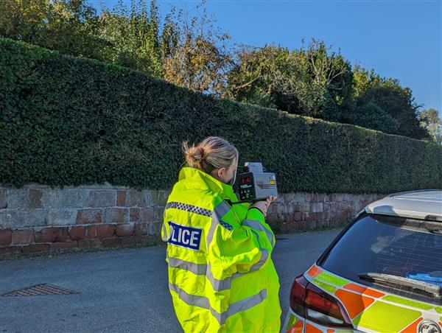 | PCs Millerchip & Harper conducted speed checks in Clive on 6th September following raised concerns of speeding vehicle around the school.

Wem Carnival
It was Carnival time in Wem on the 3rd September officers form the SNT were joined by colleagues from Oswestry to ensure the day passed without incident.
Everyone was out enjoying the glorious weather and everything the carnival had to offer.

Drugs Warrant in Wem
Officers from North Shropshire SNTs, Shropshire Local Organised Crime Team and Shropshire Neighbourhood Crime Fighting Team have conducted a drugs related warrant at an address in Wem town centre.
The warrant was executed at an address on Crown Street at 1100am on Tuesday 26th September.
Several cannabis plants were seized from the address and a man has been arrested on suspicion of Cultivation of Cannabis, he remains in police custody whilst enquiries continue.

School Visit
During the course of September Wem SNT have been visiting schools in the area to deliver talks to staff and students around staying safe online and whilst they are out and about.  Pictured PC Johnson outside Newtown C of E Primary School. | 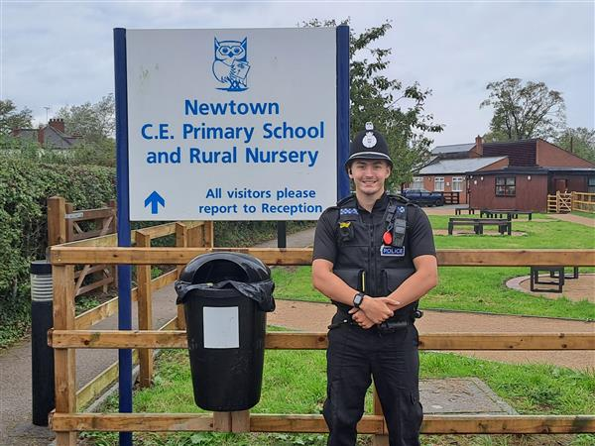

Dates for your Diary:

Sign up to Neighbourhood Matters … your brand new community messaging service
Neighbourhood Matters enables residents, businesses and community groups to keep in touch with local policing teams. You can choose exactly what type of alert you wish to receive and how you receive them; whether that be by email, text or telephone.
Sign up now at: www.neighbourhoodmatters.co.uk

